Bangladesh Medical Association (BMA)
List of Life Member-54
35. BMA Madaripur Branch

Sl No | Voter No | Voter Details
1 | Voter No  LM-3500001  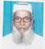 | DR. ALHAJ MD. NURUL HOQUE  F/Name: Late Soab Ali Hawlader  M/Name:  BM & DC Reg. No:  NID:  Cell:  Address: Shahid Manik Sarak,  Tarmugria,  Madaripur  Blood Group:
2 | Voter No  LM-3500002  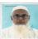 | DR. MD. MAQBUL HOSSAIN  F/Name: Late Alhaj Faizuddin Sheikh  M/Name:  BM & DC Reg. No:  NID:  Cell:  Address: Saider Bali,  Madaripur.  Blood Group:
3 | Voter No  LM-3500003  No Image | DR. MANOWARA BEGUM  F/Name:  M/Name:  BM & DC Reg. No:  NID:  Cell:  Address: TRANSFERED to BMA Dhaka City  LM-2873.  Blood Group:  TRANSFERED to BMA Dhaka City  LM-1405543
4 | Voter No  LM-3500004 | DR. MD. GOLAM SARWAR  F/Name: Late Al-haj Md. Ramizuddin Ahmmed,  M/Name:  BM & DC Reg. No: 8944  NID:  Cell: 01712289949  Address: Rawshan Vila, Hamid Akand Road, Madaripur.  Blood Group:
5 | Voter No  LM-3500005  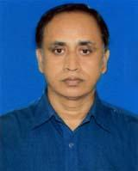 | DR. MD. LUTFAR RAHMAN  F/Name: Al-haj Master Abdul Jalil Moral  M/Name:  BM & DC Reg. No: 19424  NID:  Cell: 01712710099  Address: Master Colony,  Madaripur.  Blood Group:
6 | Voter No  LM-3500006  No Image | DR. MD. WAHIDUZZAMAN AKHANDA  F/Name:  M/Name:  BM & DC Reg. No:  NID:  Cell:  Address: Madaripur  Blood Group:  TRANSFERED to BMA Dhaka City  LM-1405543
7 | Voter No  LM-3500007  No Image | DR. SALEHA BEGUM  F/Name:  M/Name:  BM & DC Reg. No:  NID:  Cell:  Address: Niribili Panisatra R/A,  Madaripur.  Blood Group:
8 | Voter No  LM-3500008 | DR. MD. MOSHIUR RAHMAN  F/Name: Late Hafiz Md. Sayedur Rahman  M/Name:  BM & DC Reg. No:  NID:  Cell:  Address: New Town,  Madaripur.  Blood Group:
9 | Voter No  LM-3500009 | DR. A.K.M. SOBHAN MOORAL  F/Name:  M/Name:  BM & DC Reg. No:  NID:  Cell:  Address: 22/7 Dhakisswari Road  Palasshy, Dhaka.  Blood Group:
10 | Voter No  LM-3500010 | DR. MD. LIAQUAT ALI KHAN  F/Name:  M/Name:  BM & DC Reg. No:  NID:  Cell:  Address: Medical Oficer,  Sadar Hospital,  Madaripur.  Blood Group:
11 | Voter No  LM-3500011 | DR. MIZANUR RAHMAN MIAH  F/Name:  M/Name:  BM & DC Reg. No:  NID:  Cell:  Address: Registrar, Eye Dept.  S.S.M.C & Mitford Hospital,  Dhaka.  Blood Group:
12 | Voter No  LM-3500012 | DR. MUHAMMAD SHAHIDUL ISLAM  F/Name: Late Abdul Jabbar Hawlader  M/Name: Mes. Firoja Begum  BM & DC Reg. No: 15271  NID:  Cell:  Address: New Town,  Madaripur.  Blood Group:
13 | Voter No  LM-3500013  No Image | DR. WALIUL ISLAM KHAN  F/Name:  M/Name:  BM & DC Reg. No:  NID:  Cell:  Address: Vill. Khagdi, P.O. Charmugria,  Madaripur.  Blood Group:
14 | Voter No  LM-3500014  No Image | DR. MASUDUL ALAM  F/Name:  M/Name:  BM & DC Reg. No:  NID:  Cell:  Address: Transfered to BMA Mymensingh Branch  Blood Group:  TRANSFERED to BMA Dhaka City  LM-1405543
15 | Voter No  LM-3500015  No Image | DR. AL HAZ KAZI HABIBUR RAHMAN  F/Name:  M/Name:  BM & DC Reg. No:  NID:  Cell:  Address: RMO., Sadar Hospital,  Madaripur.  Blood Group:
16 | Voter No  LM-3500016  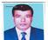 | DR. A.M MOZIBUL HAQUE  F/Name:  M/Name:  BM & DC Reg. No:  NID:  Cell:  Address: RMO., Sadar Hospital,  Madaripur.  Blood Group:
17 | Voter No  LM-3500017  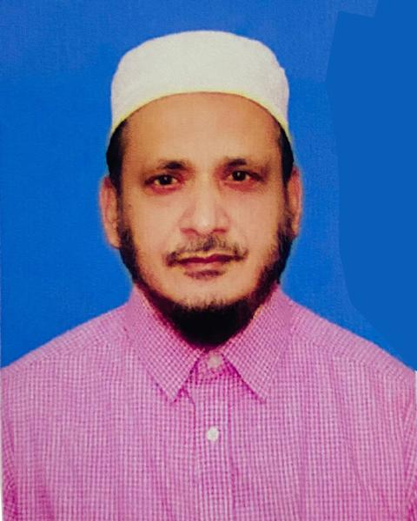 | DR. ABDUS SOBHAN  F/Name:  M/Name:  BM & DC Reg. No: 20771  NID:  Cell: 01736700047  Address: C/O. Head Master Al-Haj Aminuddin High School, Madaripur  Blood Group:
18 | Voter No  LM-3500018  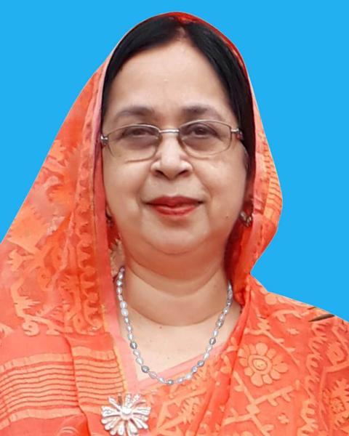 | DR. NAZMA HAQUE  F/Name: Late Al Haj Sarful Haque  M/Name:  BM & DC Reg. No: 18395  NID:  Cell: 01911381215  Address: Medical Officer, Sadar Hospital,  Madaripur.  Blood Group:
19 | Voter No  LM-3500019  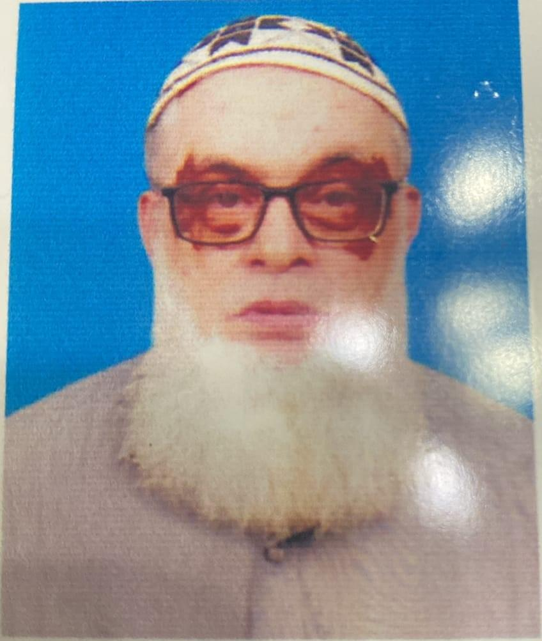 | DR. MD. AKKAS ALI  F/Name: Late Md. Kubbat Ali  M/Name:  BM & DC Reg. No: 10975  NID:  Cell: 01716519022  Address: Consultant, Eye Dept.  Sadar Hospital,  Madaripur.  Blood Group:
20 | Voter No  LM-3500020  No Image | DR. MOHAMMAD RASHIDUL ISLAM  F/Name: Late Abdul Hamid  M/Name:  BM & DC Reg. No:  NID:  Cell:  Address: Consultant, Medicine,  Sadar Hospital,  Madaripur.  Blood Group:
21 | Voter No  LM-3500021  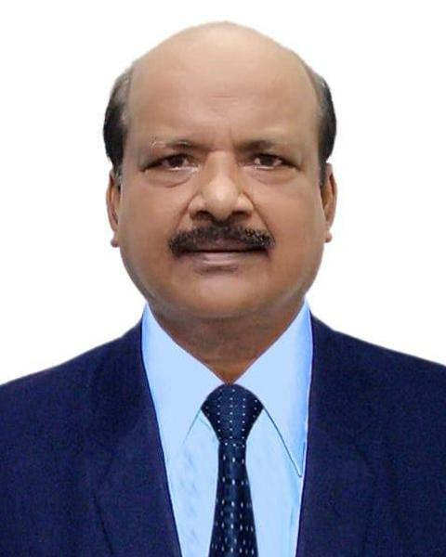 | DR. MOSTAQUE HOSSAIN TUHIN  F/Name: Late Dr. M.a. Quashem  M/Name:  BM & DC Reg. No: 14215  NID:  Cell: 01715049580  Address: Consultant Surgery, Sadar Hospital, Madaripur.  Blood Group:
22 | Voter No  LM-3500022 | DR. SHYAMAL KRISHNA BANIK  F/Name: Sontosh Chandra Banik  M/Name:  BM & DC Reg. No:  NID:  Cell:  Address: Puran Bazar,  Madaripur.  Blood Group:
23 | Voter No  LM-3500023 | DR. SYED LEAKAT ALI  F/Name: Late Syed Eakub Ali  M/Name:  BM & DC Reg. No: 17251  NID:  Cell: 01712288376  Address: Thana Health Complex Kalihati, Madaripur.  Blood Group:
24 | Voter No  LM-3500024  No Image | DR. MUHAMMAD MUSLEMUDDIN  F/Name: Late Muhd. Sakiluddin  M/Name:  BM & DC Reg. No:  NID:  Cell:  Address: Medical Officer,  Sadar Hospital,  Madaripur.  Blood Group:
25 | Voter No  LM-3500025  No Image | DR. MD. FARID UDDIN  F/Name: Mow. Burhan Uddin  M/Name:  BM & DC Reg. No:  NID:  Cell:  Address: Panichatra,  Madaripur  Blood Group:
26 | Voter No  LM-3500026  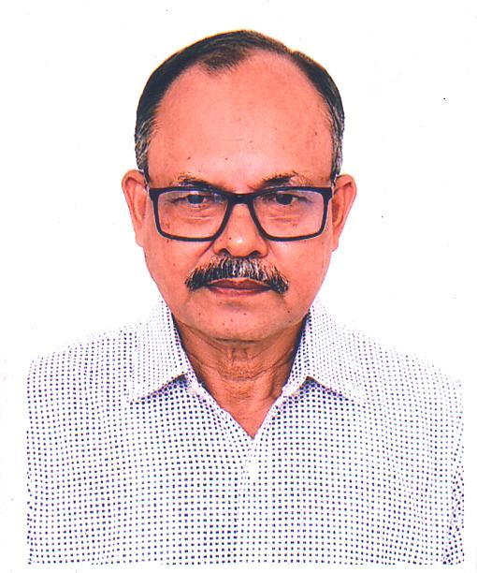 | DR. MD. A. WADUD MIAH  F/Name: Late Alhaj A. Satter  M/Name:  BM & DC Reg. No: 15951  NID:  Cell: 01711574781  Address: Tarmugaria Master Colony, Madaripur.  Blood Group:
27 | Voter No  LM-3500027  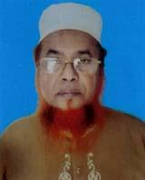 | DR. MD. AFZAL HOSSAIN  F/Name: Md. Forhad Hossain  M/Name:  BM & DC Reg. No: 15945  NID:  Cell: 01715399285  Address: Sardar Colony, New Town, Madaripur.  Blood Group:
28 | Voter No  LM-3500028  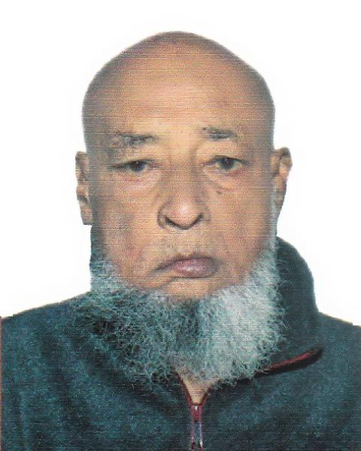 | DR. MD. SIKANDER ALI  F/Name: Munshi Maminuddin  M/Name:  BM & DC Reg. No: 5796  NID:  Cell: 01715477787  Address: Deputy Director Dhaka Medical College Hospital Dhaka  Blood Group:
29 | Voter No  LM-3500029  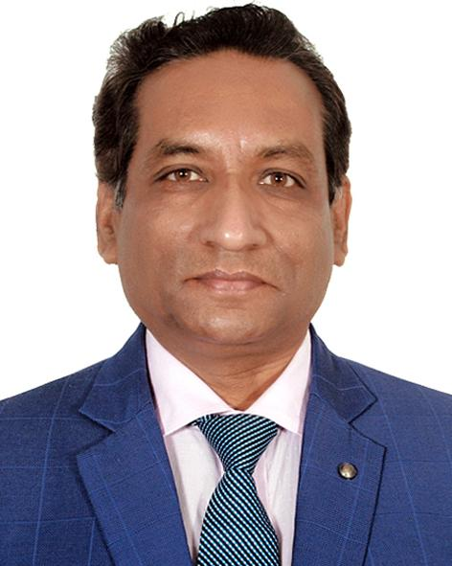 | DR. SHAKTI RANJAN MANDAL  F/Name: Sarat Chandra Mandal  M/Name:  BM & DC Reg. No: 22936  NID:  Cell: 01712291532  Address: Pathakkhandi, Madaripur  Blood Group:
30 | Voter No  LM-3500030  No Image | DR. MD. HUMAYUN KABIR  F/Name: Al Haj Md. Abdul Ali Miah  M/Name:  BM & DC Reg. No:  NID:  Cell:  Address: Medical Officer,  Civil Surgeon Office,  Madaripur.  Blood Group:
31 | Voter No  LM-3500031  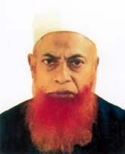 | DR. MD. ALTAF HOSSAIN  F/Name: Md. Forhad Hossain  M/Name:  BM & DC Reg. No: 15318  NID:  Cell: 01716341586  Address: Hamid Sikder Sarok,  New Town.  Madaripur.  Blood Group:
32 | Voter No  LM-3500032 | DR. MD. SIDDIQUR RAHMAN  F/Name: Md. Chand Mahmaud Howlader  M/Name:  BM & DC Reg. No: 13910  NID:  Cell: 01916879933  Address: Medical Officer,  T.B Clinic.  Madaripur.  Blood Group:
33 | Voter No  LM-3500033  No Image | DR. MD. ABUL KALAM AZAD  F/Name:  M/Name:  BM & DC Reg. No:  NID:  Cell:  Address: Transfered to BMA Bagerhat Branch  LM-08  Blood Group:  TRANSFERED to BMA Dhaka City  LM-1405543
34 | Voter No  LM-3500034  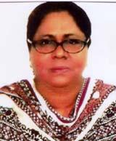 | DR. RUNIA BEGUM  F/Name: Motiar Rahman Mollah,  M/Name:  BM & DC Reg. No: 21130  NID:  Cell: 01712552817  Address: Master Colony, Madaripur.  Blood Group:
35 | Voter No  LM-3500035  No Image | DR. ANWARA BEGUM  F/Name: Mr. M.a. Zaher  M/Name:  BM & DC Reg. No:  NID:  Cell:  Address: Medical Officer, Thana Health Complex, Ghior, Manikgonj.  Blood Group:
36 | Voter No  LM-3500036 | DR. MD. ABDUL MAZID KHAN  F/Name: Al-haj Abdul Sattar Khan  M/Name:  BM & DC Reg. No: 21127  NID:  Cell: 01714998257  Address: Charmugaria, Madaripur.  Blood Group:
37 | Voter No  LM-3500037  No Image | DR. MD. ANOWAR HOSSAIN HOWLADER  F/Name:  M/Name:  BM & DC Reg. No:  NID:  Cell:  Address: TRANSFERED to BMA Barisal Br.  LM-171.  Blood Group:  TRANSFERED to BMA Dhaka City  LM-1405543
38 | Voter No  LM-3500038  No Image | DR. SYED SHAHIDUL ISLAM SHAHID  F/Name:  M/Name:  BM & DC Reg. No:  NID:  Cell:  Address: TRANSFERED to Dhaka City.  LM-1402886.  Blood Group:  TRANSFERED to BMA Dhaka City  LM-1405543
39 | Voter No  LM-3500039  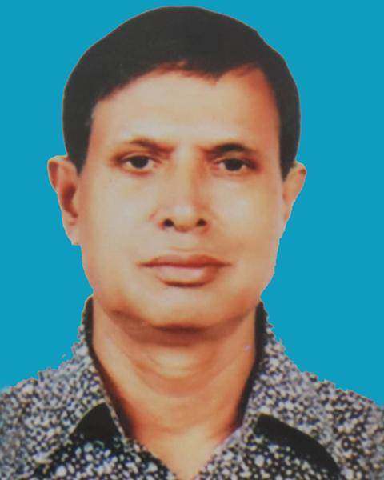 | DR. MD. HARUN-UR-RASHID  F/Name: Md. A. Wahed Miah  M/Name:  BM & DC Reg. No: 11948  NID:  Cell: 01717182018  Address: Junior Consultant, Medicine Dept., Sadar Hospital, Madaripur.  Blood Group:
40 | Voter No  LM-3500040  No Image | DR. TAUFIQUA HUSSAIN  F/Name: Md. Tazammel Hussain  M/Name:  BM & DC Reg. No:  NID:  Cell:  Address: Madaripur Sadar Hospital,  Madaripur.  Blood Group:
41 | Voter No  LM-3500041 | DR. NASRIN ROSF  F/Name: Abdul Hakim Howlader  M/Name: Noorjahan Begum  BM & DC Reg. No: 22199  NID: 2691650158022  Cell: 01715253207  Address: Junior Consultant (Gynae), UHC, Kalkini, Madaripur  Blood Group: A+
42 | Voter No  LM-3500042  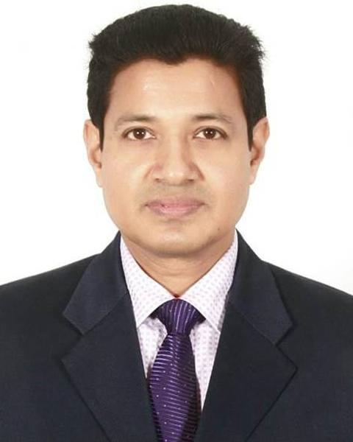 | DR. PRANESH KUMAR BAIDYA  F/Name: Late Dr. Shyamacharan Baidya  M/Name:  BM & DC Reg. No: 29157  NID:  Cell: 01556344057  Address: Baidya Bhaban, Amirabad, Badamtola Road, Madaripur.  Blood Group:
43 | Voter No  LM-3500043  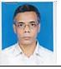 | DR. MD. ABDUL JABBER HOWLADER  F/Name: Late A. Gani Munshi  M/Name: 01715452070  BM & DC Reg. No:  NID:  Cell:  Address: N/A  Blood Group:
44 | Voter No  LM-3500044  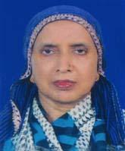 | DR. KHALIDA AKHTER KHANAM  F/Name: Late Abdul Hamid Akhand  M/Name:  BM & DC Reg. No: 9554  NID:  Cell: 01711489706  Address: Madaripur  Blood Group:
45 | Voter No  LM-3500045  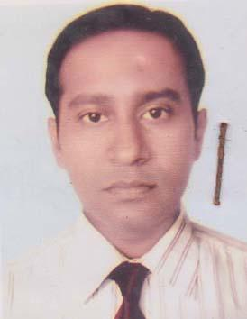 | DR. DEBABRATA HALDER  F/Name: Chitta Ranjan Halder  M/Name: Sova Rani Halder  BM & DC Reg. No: 30031  NID: 19735425406000004  Cell: 01711004797  Address: Govt. Staff Quarter, Madaripur  Blood Group: A+
46 | Voter No  LM-3500046 | DR. SHAWKAT HOSSAIN SWAPAN  F/Name: Mohammad Saheb Ali  M/Name: Taslima Begum  BM & DC Reg. No: 53708  NID: 2698878294129  Cell: 01677319742  Address: Vill- Ghikarhati, P.O- Ghatmajhi, P.S & Dist: Madaripur  Blood Group: O+
47 | Voter No  LM-3500047 | DR. MD. SALIM MIAH  F/Name: Late Md. Kaziruddin  M/Name: Late Shakhina Begum  BM & DC Reg. No: A-14225  NID:  Cell:  Address: Vill- Jaduar Char,  Po:- Banhamgonj , Ward -4,  Shibchar Pourosara, Madaripur.  Blood Group:
48 | Voter No  LM-3500048 | DR. ABDUL WAHAB HOWLADER  F/Name: Late Kazem Howlader  M/Name:  BM & DC Reg. No:  NID:  Cell:  Address: Vill : Purahit Bari, Purbamaijpara, P.O. : Birmohan,  P.S. : Dasar, U.Z. : Kalkini,  Zilla : Madaripur.  Blood Group:
49 | Voter No  LM-3500049  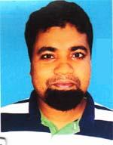 | DR. MD. ABDUL BASET  F/Name: Md. Abdul Karim  M/Name: Mst. Amena Khatun  BM & DC Reg. No: 41504  NID: 19818198502162101  Cell: 01816323663  Address: Staff Quarter, Sadar Hospital, Madaripur  Blood Group: A+
50 | Voter No  LM-3500050 | DR. SASHANKA CHANDRA GHOSE  F/Name: Ram Narayan Ghose  M/Name: Hashya Bala Ghose  BM & DC Reg. No: 39966  NID: 19785415410252981  Cell: 01911303361  Address: Doctors Quarter, Sadar Hospital, Madaripur  Blood Group: O+
51 | Voter No  LM-3500051 | DR. KHAJA BADRUDDOZA  F/Name: M. Abdul Karim  M/Name: Mariam Karim  BM & DC Reg. No: 53795  NID: 0695111184830  Cell: 01712638399  Address: C/O M. Abdul Karim, Master Colony Madaripur  Blood Group: A+
52 | Voter No  LM-3500052 | DR. MAHMUDA AFROJ  F/Name: Ataur Rahman  M/Name: Ferdoshi Rahman  BM & DC Reg. No: 61306  NID: 0695112194135  Cell: 01739500400  Address: Panichatra, Madaripur  Blood Group: AB+
53 | Voter No  LM-3500053 | DR. MD. RIAD MAHMUD  F/Name: Md. Saidur Rahman  M/Name: Rina Said  BM & DC Reg. No: 66376  NID: 0695111185446  Cell: 01719973220  Address: New Town, Main Road, Battala (Charmadanray), Madaripur  Blood Group: B+
54 | Voter No  LM-3500054 | DR. EKRAM HOSSEN  F/Name: Tayoubali Howlader  M/Name: Afsaron Neesa  BM & DC Reg. No: 36943  NID: 54254012825  Cell: 01711304110  Address: 1 No. Sakuni, College Road Sadar, Madaripur  Blood Group: O+

